Energy Trading & Risk Management with MATLAB

The case study presented here demonstrates using MATLAB to build an application for measuring the risks associated with a portfolio of gas-fired power plants operated in New England. The application has an interface implemented in Excel with all of the analytics performed by MATLAB. The application allows the user to specify the characteristics of the 7 plants including the capacity, heat rate, variable operation and maintenance costs and minimum run time. This portfolio can be backtested using a simple dispatch strategy on historical gas and electricity prices to compute historical profit and plant operation statistics. The risk measures are computed by simulating gas and electricity prices into the future using a hybrid model implemented in MATLAB, simulating the dispatch for each scenario of market prices and computing cash-flows arising from the operation of the plants. The distribution of the cash-flows is analyzed to produce a 90% and 95% cash-flow at risk measure for each plant as well as for the portfolio of generation assets. All of this functionality is presented with a succinct Excel front end.
This document describes building the application in the MATLAB environment. The case study is designed to demonstrate the broader capabilities of MATLAB products and as such leverages functions from a number of toolboxes. The required products are highlighted in each section. In some cases there may be alternate ways to perform the same analysis. These will also be specified.

1. Installation & Setup
* Note: The data used in this application is not provided with the MATLAB Central File Exchange entry. The data can be obtained from the New England ISO at http://www.iso-ne.com/. The Natural Gas spot price data can be obtained from the Wall Street Journal at http://www.wsj.com. You can still view the results of running each script on the data by viewing the MATLAB-generated reports included in the archive.
The only installation requires defining the Access database used as the example's primary data source. The database is not required for the analysis in MATLAB but is required for the Excel Risk application. This database, located in "CaseStudy\Data\energy.accdb" must be defined as an ODBC data source named "EnergyRisk" in Windows. To do so,
1. In Windows, navigate to "Control Panel -> Administrative Tools -> Data Sources (ODBC)"
2. Click "Add..."
3. Select Microsoft Access Driver and Finish
4. Under the Database tab, click "Select..." and navigate to "energy.accdb" under CaseStudy\Data and hit OK
6. Give it the name EnergyData and hit OK

2. Importing Data from the Database
Products Required: Database Toolbox
The data can be quickly imported using Database Toolbox's Visual Query Builder. Launch the Visual Query Builder by running querybuilder in MATLAB or by clicking the MATLAB start button and navigating to "Toolboxes -> Database Toolbox -> Visual Query Builder". Once data is imported, MATLAB code can be generated to automate the process. The function fetchDBElecData is one such auto-generated function which has been further customized to allow the user to pass a begin and end date for the data import. This function is used by the Excel interface.

3. Building the Model
The model used for simulating electricity prices is a reduced-form hybrid model as depicted in Figure 1 below. Its fundamental drivers are natural gas prices and temperatures. The model internally captures relationships between the drivers and electricity prices as well as the relationships to time of day, day of the week and holidays. The natural gas price model is a reduced form mean-reverting stochastic differential equation model. The temperature model is a combination of a parametric function and a time series model. The simulated natural gas and electricity price paths are fed into a dispatch algorithm which computes optimal dispatch of the plant to produce a series of cash-flows which can be used to compute the cash-flow at risk measures.
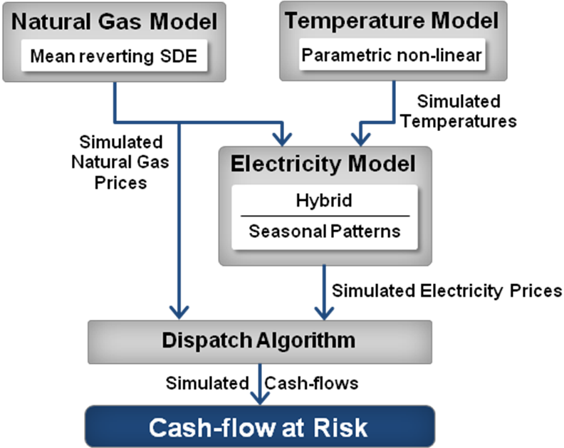
Figure 1. Cash-flow at Risk Algorithm/Model Structure
The following scripts demonstrate building the different components of the hybrid model & dispatch engine. If you do not have the required products, you can still view the outputs of running the scripts in the html reports folder. These reports have been generated using the MATLAB publish feature. In some cases the comments in the scripts also mention other functions that can be used to perform the same computations.
Script | Description | Required Toolboxes | Optional Toolboxes | Launch Reports
ModelNGPrice.m | Model & Simulate Natural Gas Prices | Econometrics |  | Report
ModelTemperature.m | Model & Simulate Temperatures | Curve Fitting, Statistics | Econometrics | Report
ModelElectricity.m | Model & Simulate Electricity Prices | Statistics | Econometrics | Report
SimulationDispatch.m | Simulate Hybrid Model & Dispatch | Econometrics, Curve Fitting, Statistics |  | Report

4. Running the Excel Application
Products Required: Spreadsheet Link EX
There are three Excel spreadsheets included in the application.
- PlantRiskDeployed.xlsm is the interface that is used with the deployed application. It includes VBA code that calls deployed methods of the COM DLL created with MATLAB Builder Ex. The deployment project PlantRisk.prj includes the relevant files needed for building the deployed application. This can be opened in MATLAB and built to create the DLL needed by the Excel application. The VBA code in vbamodule.bas contains VBA code that is already a part of PlantRiskDeployed to automate calling the DLL functions from Excel.
- PlantRiskSpLink.xlsm is the interface that is used with Spreadsheet Link EX to call MATLAB functions in a running session of MATLAB. This version is useful if either you don’t need to share the application with other people who are not users of MATLAB or to prototype the interface before creating the deployed application.
- PlantRiskTemplate.xlsx is the plain interface with no integration to MATLAB. The VBA code in vbamodule.bas as well as the VBA code generated by MATLAB Builder EX can be imported into this file to make it a fully functional deployed application identical to PlantRiskDeployed.xlsm

Using the interface:
Clicking the Run Backtest button calls the backtestPlantPortfolio function (either in MATLAB or in the MATLAB-generated DLL). This function loads historical electricity and natural gas prices for the date range specified on the worksheet and computes a daily optimal dispatch for each generator which maximizes the daily generation profit while respecting minimum run time constraints. The result of the backtest is a set of operational statistics for each plant such as realized profit, number of operating days, percentage of time the plant is running and the average number of hours per operating day. The function also computes the total expected profit for the portfolio and a plot of cash-flows (profits) for every date in the date range. A screenshot of the results of the backtest is shown below.
Clicking the Run Simulation button calls the simulatePlantPortfolio function (either in MATLAB or in the MATLAB-generated DLL). This function loads pre-trained models for natural gas prices, temperatures and electricity prices and jointly simulates a number of paths for natural gas and electricity prices for the date range specified. The number of simulations can be specified on the worksheet. The optimal dispatch is then carried out for each plant for each path of simulated prices to compute profit and operational statistics for each plant as well as the portfolio as a whole. These are then averaged and displayed on the worksheet .In addition a cash-flow at risk measure is computed for each asset and the portfolio. The function also creates a histogram plot of the cash-flow (earnings) distribution with the risk metrics highlighted.
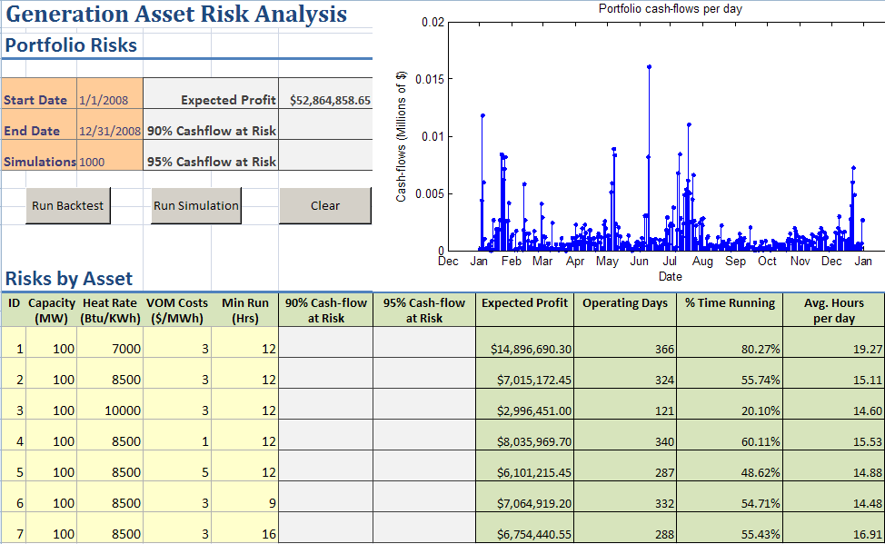
Figure 2. Result from running a backtest
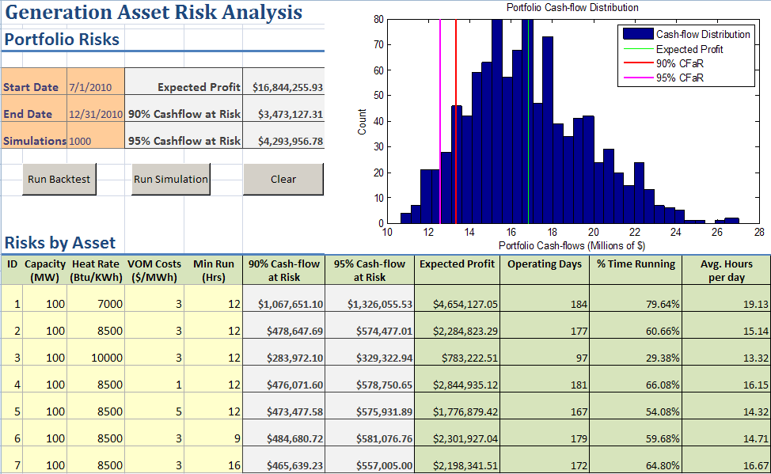
Figure 3. Result from running a simulation

Appendix A: Table of Files in Archive

File | Description

Main Analysis Scripts
ModelNGPrice.m | Model & simulate Natural Gas prices
ModelTemperature.m | Model & simulate hourly temperatures
ModelElectricity.m | Model & simulate Electricity prices
SimulationDispatch.m | Simulate electricity hybrid model, simulate dispatch and compute cash-flow at risk

Helper Functions
fitPlot.m | Create plot of series, model-predicted series and residuals
dynamicDateTicks.m | Apply date ticks to plots that update with zooming and panning.
dispatch.m | Compute optimal dispatch for a generator for a series of historical or simulated natural gas and electricity prices
genPredictorsElec.m | Generate a matrix of predictors (temperatures, fuel prices and day/week/holiday) for each electricity price observation
fetchNGData.m | Import natural gas historical prices from Energy database
fetchDBElecData.m | Import temperatures and electricity prices from Energy database
simulateNGPrices.m | Simulate natural gas prices given model and date range
simulateTemperature.m | Simulate temperatures given model and date range
simulateElecPrices.m | Simulate electricity prices given model, date range, natural gas prices and temperatures

PlantRisk Excel Application Functions
backtestPlantPortfolio.m | Backtest dispatch algorithm on historical prices and produce a set of cash-flows and operational characteristics of plant portfolio (used by Excel application)
simulatePlantPortfolio.m | Simulate natural gas and hybrid electricity model to generate scenarios, run dispatch on each scenario to compute cash-flows and cash-flow at risk (used by Excel application)

Other Files
PlantRisk.prj | Deployment project file that can be used with MATLAB Builder EX to build the DLL required for the Excel application
vbamodule.bas | VBA code included in the archive to complete the Excel application

